A PERSONAL WORKBOOK BY CHRIS NUGENT

Quiet Self Recovery
  - Insight into How I Dealt with My Trauma
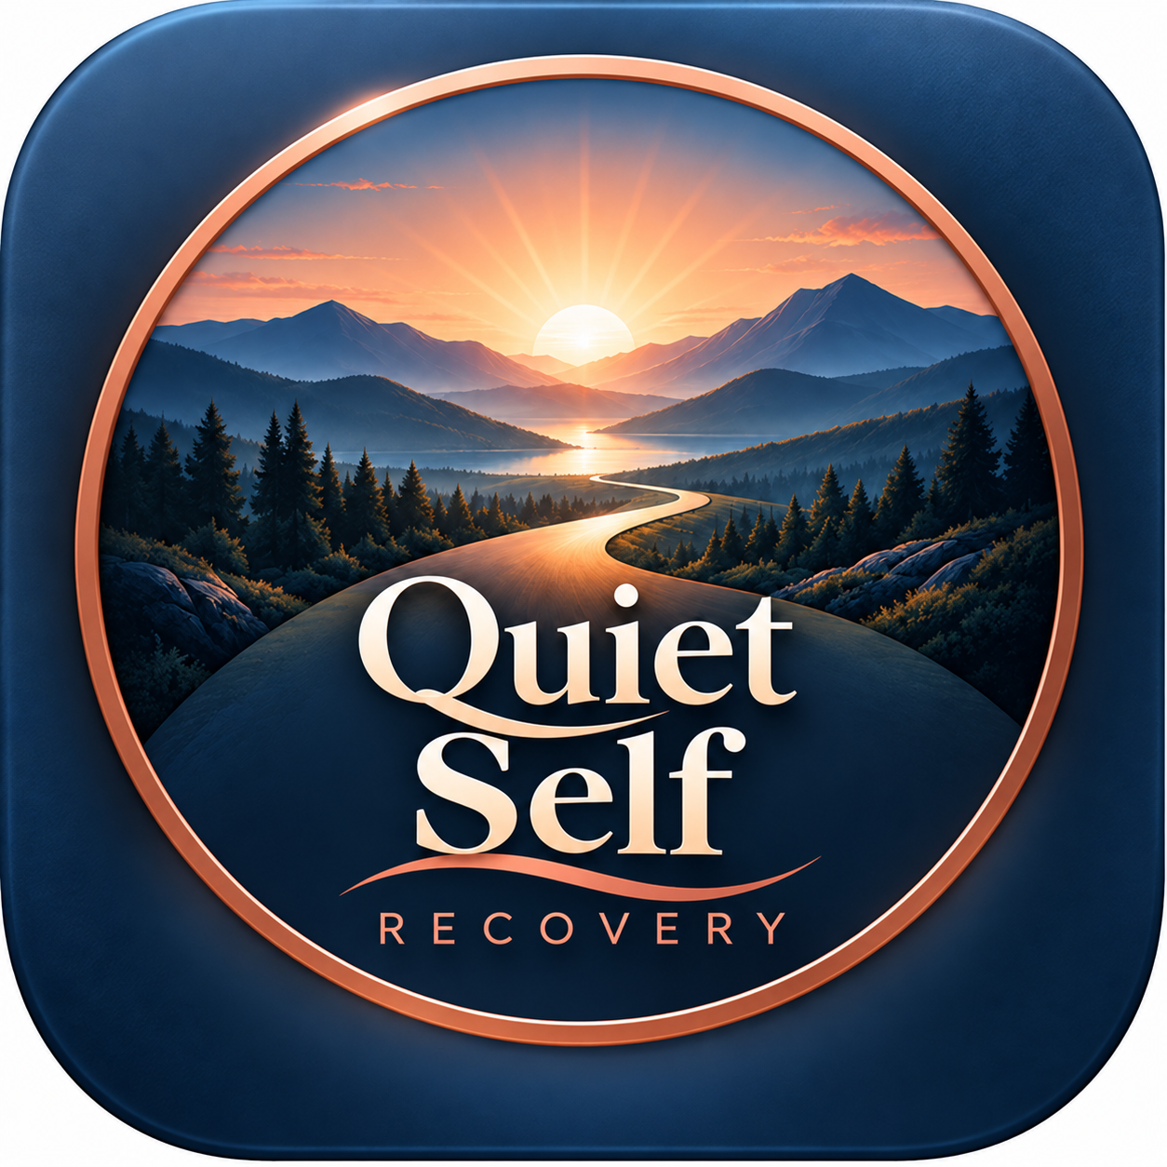
A workbook to complete privately at your own pace.
My understanding of recovery and the things that helped me and still help me. Original reflections and optional exercises for adults aged 18 and over.
Chris Nugent | QSRecovery | October 2026
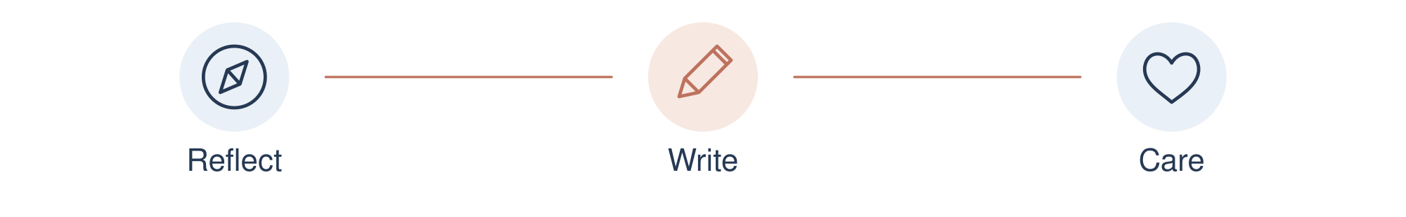
01 This copy belongs to me

THE WORKBOOK

A note from me
CHRIS NUGENT | PERSONAL EXPERIENCE
I'm Chris Nugent. I'm not a therapist or a clinical professional. This workbook comes from my own understanding of trauma and recovery, and from what helped me and still helps me.
My own recovery has included AA and ACOA. Honesty, meetings, routine and connection matter to me. I have also wanted to understand the patterns I carried from childhood into adult life. I care about taking responsibility for what I do now while learning to speak to myself with more kindness.
I have brought together original reflections and prompts here. Learning about Gabor Maté's work and the adult children recovery tradition has influenced my understanding. Their work is acknowledged, but this is an independent QSR workbook. It is not their publication or an authorised version of their programmes.
The letters, lists and photo exercise are invitations for your own reflection. They are not tests, diagnostic tools or treatments. I cannot tell you what your past means or promise a particular result.
You decide what to answer and what to leave. You can write, type, draw or simply think. You do not have to share anything you put here. If a page becomes too much, stop and get the support you need.
For me, recovery includes learning what I need and being honest about how I treat myself and other people. You have room to find your own words and your own pace.
Influences acknowledged in references 1 to 4. All workbook prompts are original. Sources and links are on pages 40 to 42.


THE WORKBOOK

Using this workbook
YOUR CHOICE AND YOUR PACE
There is no deadline or required order. Start with a page that feels manageable. The love list can be a gentle place to begin. Leave the letters and photograph until you feel ready, if you choose to use them at all.
Use a pencil or pen, or type into the editable Word version. Continue on another sheet whenever you want.
Print on A4 at Actual size or 100 percent. The margins leave room for binding. Single-sided pages give more space for writing; double-sided printing is also an option. Section words and symbols are retained in black and white.
Keep your writing and photographs somewhere private. There is no need to upload them, send them to me or show them to anyone. Sharing with someone you trust is your choice.

Find a page
Getting ready and my understanding 4 to 6
Patterns and needs 7 to 8
Optional writing with your other hand 9 to 10
Letters to your younger and adult self 11 to 14
A younger photograph and a kind message 15 to 17
Fears and love lists 18 to 21
Recognising differences and the QSR model 22 to 30
Compassionate discovery and everyday choices 31 to 36
Difficult days and looking ahead 37 to 39
Sources and support 40 to 42
What the tasks are meant to help with 43 to 49
Pause whenever you need to. Returning later, choosing a different page or deciding that an exercise is not for you are all valid choices.

01 MAKING ROOM Date __________

Before I begin
MAKE ROOM FOR CHOICE
Choose a place where you feel reasonably settled and can stop freely. You do not need to bring up detailed memories to use this workbook.
If you feel flooded, panicky or disconnected, put the workbook down. Look around, name where you are, notice something ordinary in the room, and contact support if needed. Eyes can stay open. A breathing exercise is optional; leave it if it makes you uncomfortable.
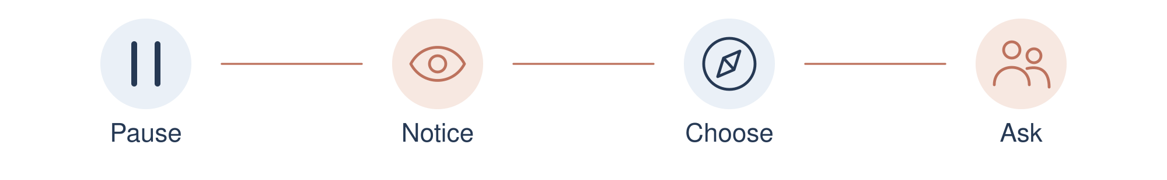
01 What would make this a manageable time to reflect

02 What will tell me that I need to pause

03 What ordinary thing could help me return to the present

04 Who or what support could I contact if I need help

For professional and urgent support see references 6 to 8. Sources and links are on pages 40 to 42.

01 MAKING ROOM Date __________

What I understand about trauma
MY UNDERSTANDING | NOT A DIAGNOSIS
My starting point is to be curious about how difficult experiences may still affect the way I see myself, react or relate to people. I do not use this workbook to decide whether someone has a disorder or to explain every problem through childhood.
Gabor Maté's writing has influenced my attention to pain, stress and compassion. ACOA has influenced my interest in patterns learned in family life and in developing a kinder relationship with myself. These are influences on my thinking, rather than a clinical method I am qualified to deliver. [1 to 4]
People have different histories. Trauma can contribute to difficulties, but addiction has several contributing factors. This workbook does not assume that everyone in recovery has the same cause or story. [5]
There is no need to search for forgotten events. Feelings, images and imagined letters are not evidence that a particular event occurred. You can work with what you notice in everyday life now.
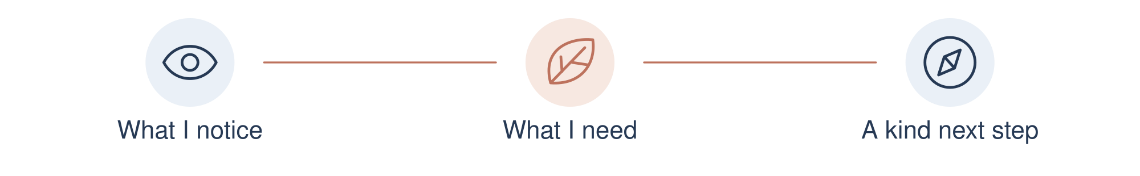
01 What would I like to understand about the way I treat myself today

02 What would I like this workbook to make room for

01 MAKING ROOM Date __________

What helps me
CHRIS NUGENT | PERSONAL RECOVERY
Honest conversations, recovery meetings and ordinary routines have been part of what helps me. They give me ways to notice my behaviour, ask for help and practise living differently. I want kindness to be part of that everyday work.
I have included simple spaces for you to recognise what already helps you. Your list can look different from mine. A meeting may suit one person; a trusted conversation, professional support or time outside may suit another.
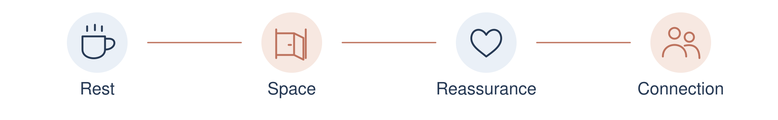
01 What already helps me feel more settled or connected

02 What would I like to do a little more regularly

03 What support do I need to make that realistic

An ordinary helpful thing is enough. You do not need an impressive answer.

01 MAKING ROOM Date __________

What I learnt to do
You might recognise a habit such as keeping quiet, pleasing people, doing everything yourself or watching for changes in someone else. Choose one that fits your own experience, or name a different habit. You do not have to work out exactly where it began.
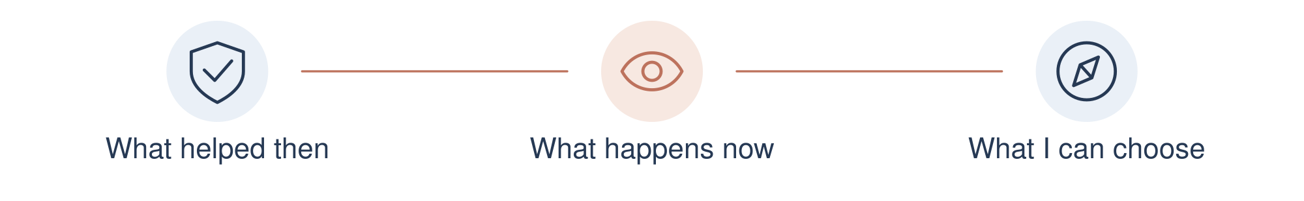
01 One habit I notice in myself

02 What I think it may have helped me manage at the time

03 When it helps me today and when it gets in the way

You can understand a habit without blaming yourself for having learned it.
Broad family pattern themes are acknowledged in references 3 and 4. This exercise is original. Sources and links are on pages 40 to 42.

01 MAKING ROOM Date __________

What I need today
Stay with one everyday situation. The aim is to notice a need and a manageable choice, rather than judge your whole life.
01 An ordinary situation where I find things difficult

02 What I feel or notice in that situation

03 What I need: rest, clarity, space, help or reassurance

04 One way I could ask for or give myself that support

A need can be real even when I cannot meet all of it today.

02 WRITING YOUR WAY Date __________

Writing with my other hand
OPTIONAL WRITING EXPERIMENT
If it feels comfortable, try a few words with the hand you normally use less. Let the writing be untidy. You can use your usual hand, type, speak into a private note or skip this experiment.
I have included this as a way to try a different pace while reflecting. It is not a validated trauma treatment or a way to recover memories. A different hand does not tell you which thoughts are true.

A gentle way to try it
Choose a neutral prompt such as Something kind I can do today.
Write a few words and stop whenever you want.
Notice whether it feels comfortable, frustrating or simply different.
Return to your usual way of writing if there is pain, strain or distress.
There is no need to imagine a child answering. If you choose an imagined voice in a letter, recognise that it is something you are creating today, not a recovered record of the past.
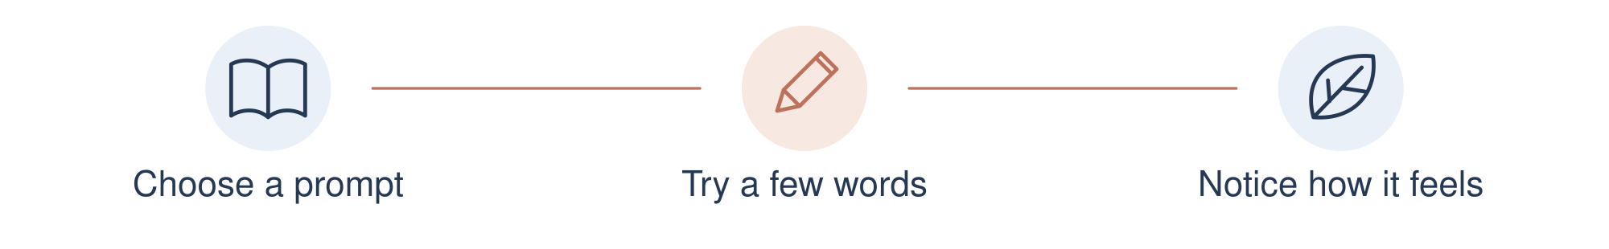
01 The prompt I choose

02 The way of writing that feels most comfortable for me

02 WRITING YOUR WAY Date __________

My other hand writing page
OPTIONAL | YOUR USUAL HAND IS ALSO FINE
Choose one gentle prompt. Stop after a few words if that is enough.
Possible starting points: Something kind I can do today. Something I enjoy. What would make this afternoon easier.

01 How this felt and what I prefer next time

03 LETTERS AND CARE Date __________

Letter to my younger self
A LETTER FOR YOUR OWN REFLECTION
Write to a younger version of yourself, at any age that feels manageable. You can speak with care without describing what happened. You can also choose a letter to yourself last week instead.
A letter is something you create in the present. It is not proof of how you felt at a particular age. If you imagine a reply, keep that distinction clear.

Possible starting points
Dear younger me, I want you to know...
You deserved...
Something I appreciate about you is...
I would like to offer you...
One thing I can do for myself now is...
There is no need to forgive anyone, reconnect with anyone or explain another person's behaviour. The letter can stay private.

01 What would I like this letter to offer

You can write one kind sentence and leave the rest.
Kindness towards the younger self is a broad influence acknowledged in reference 4. These letter prompts are original. Sources and links are on pages 40 to 42.

03 LETTERS AND CARE Date __________

My letter to my younger self
WRITE AS MUCH OR AS LITTLE AS YOU CHOOSE
Dear younger me,

A blank page is allowed. You can return whenever you choose.

03 LETTERS AND CARE Date __________

Letter to myself as an adult
KINDNESS AND HONESTY TOGETHER
Write to the person you are today. You can recognise effort and pain while also being honest about a behaviour you want to change. You do not need to attack yourself to take responsibility.

Possible starting points
Dear me, I can see that you are trying to...
Something you have carried is...
Something you are doing with care is...
Something I want to handle differently is...
The support I need for that is...
One realistic next step is...
If you write about a mistake, keep it specific. A sentence such as I spoke harshly and want to make a repair gives you something to act on.
01 What I would like to recognise about myself today

You can take responsibility for an action while still treating yourself with respect.

03 LETTERS AND CARE Date __________

My letter to myself today
YOUR WORDS | YOUR OWN PACE
Dear me,

You can finish with one manageable promise, or simply with kindness.

03 LETTERS AND CARE Date __________

Looking at a younger photograph
OPTIONAL | NO PHOTO IS REQUIRED
Choose a childhood photograph only if looking at it feels manageable. You can use a copy, look briefly and put it away, or leave this page blank. A current photograph or your written name is another option.
Notice what you can actually see. A photograph cannot tell you everything about what was happening or what you felt. There is no need to fill in gaps.
A photo can go here if I choose

01 What I can see without guessing

02 One kind thing I would like to say to this younger person

If this feels too much, put the photograph away and return to page 4.

03 LETTERS AND CARE Date __________

Offering kindness to that child
AN OPTIONAL APOLOGY OR A MESSAGE OF CARE
If an apology feels right, it can be about harsh words or neglectful ways you have treated yourself as an adult. You are not responsible for abuse or neglect you experienced as a child. You do not owe an apology for what other people did to you.
You may prefer to offer comfort or acknowledgement instead. There is no requirement to apologise, feel a particular emotion or describe a painful event.

Possible words to adapt
I am sorry you had to face things that were too much for a child.
You deserved care and protection.
If it fits: I am sorry for the harsh things I have said to myself.
I would like to treat myself with more patience now.
Today I can show that care by...
These are suggested present-day words, not a script you have to believe. Change them, leave them or write your own.
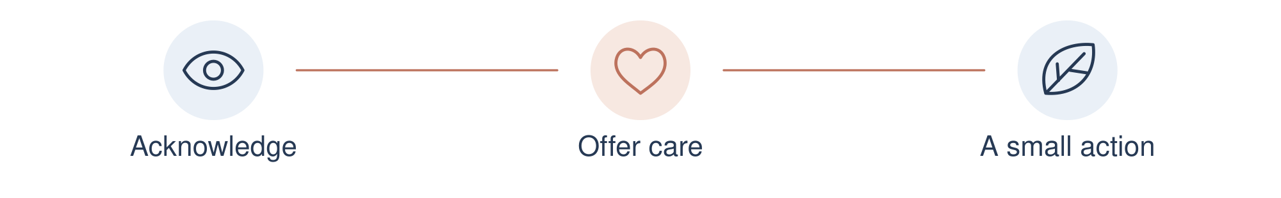
01 The message that feels most honest and kind for me

Reference 4 acknowledges a broad influence. The apology and photo exercises are original reflections, not ACA materials. Sources and links are on pages 40 to 42.

03 LETTERS AND CARE Date __________

My message to the child in the photo
OR TO A YOUNGER SELF I CHOOSE TO WRITE TO
You can begin with You deserved care, I want you to know, or your own words. You can write without using a photograph.

You are allowed to offer care without an apology.

04 FEARS AND LOVE Date __________

My fears list
NOTICE WITH KINDNESS
List only the fears you want to name today. You can keep them general. You do not need to uncover a childhood cause or put them in order of importance.
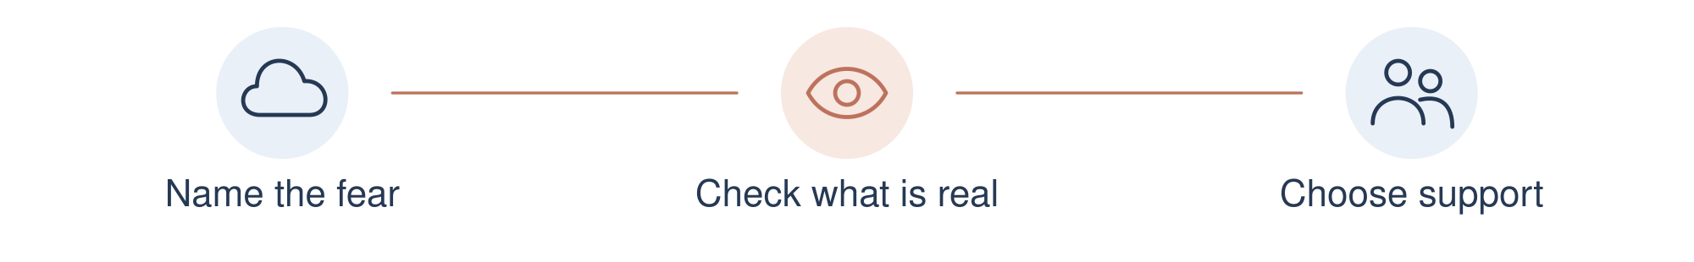
01 A fear I choose to name

02 A fear I choose to name

03 A fear I choose to name

04 A fear I choose to name

05 A fear I choose to name

06 A fear I choose to name

A fear may signal a real concern. I can seek help with safety as well as with feelings.

04 FEARS AND LOVE Date __________

Working gently with one fear
Choose a fear that feels manageable. If it involves current danger, focus on practical protection and support rather than trying to talk yourself out of it.
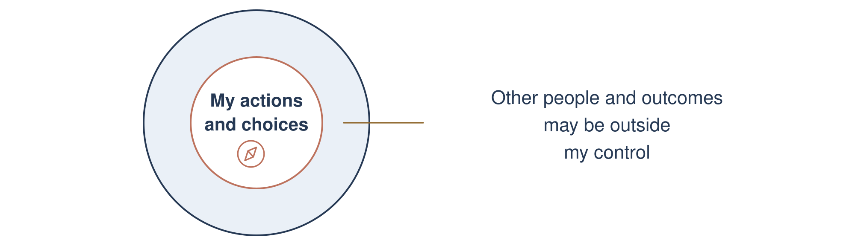
01 The fear I choose to look at

02 What I know is happening and what I am assuming

03 What I can influence and what is outside my control

04 What reassurance, practical help or protection I need

05 One small supported action I could take

You do not have to face a fear alone or prove that you are brave.

04 FEARS AND LOVE Date __________

My love list
MAKE ROOM FOR WHAT MATTERS TO YOU
Love can include small ordinary things. If love feels like too strong a word today, use things I like, things I care about or things that bring a little ease.
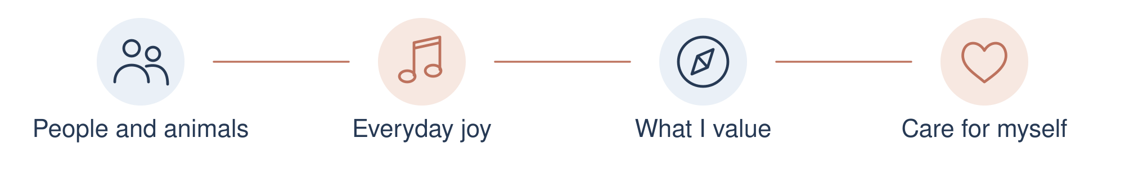
01 People or animals I feel care for and reasonably safe with

02 Places, music, activities or everyday moments I enjoy

03 Qualities or values I care about

04 Something I appreciate about myself, even a little

This is an invitation. There is no need to feel positive on demand.

04 FEARS AND LOVE Date __________

Making room for what I love
Choose something from your love list that is available and manageable. It can be a short walk, a song, a cup of tea, a creative task or an ordinary moment of connection.
01 Something I want to make room for

02 A small way I could include it this week

03 What might get in the way and what would help

04 How I will know it felt worthwhile for me

You can enjoy something without having to earn it through a perfect day.

05 RECOGNISING THE DIFFERENCES Date __________

Being alone or feeling lonely
UNDERSTANDING MY CIRCUMSTANCES AND MY FEELINGS
I find it useful to ask two different questions: who is around me, and whether I feel connected. These descriptions can overlap.
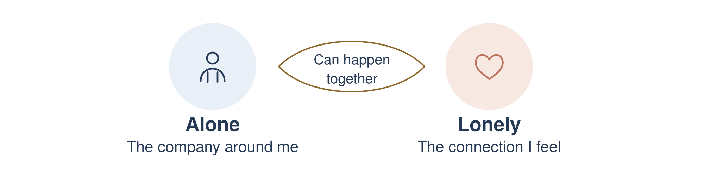

Being alone
Being alone means being without other people at that moment. Time alone can be chosen, necessary, restful or uncomfortable. It does not tell me whether I feel understood or supported.

Feeling lonely
Loneliness is the painful feeling that the connection I want is missing or insufficient. I can feel lonely while alone, in a busy room or within a relationship. The quality of connection matters as well as company. [9]
An ordinary example: an evening by myself may feel peaceful one day and lonely another. I can enjoy some quiet and still want a meaningful conversation.
01 Which description fits today, or is it a mixture

I am allowed to want both private space and connection.
Reference 9 supports the distinction. The examples and prompts are my own wording. Sources and links are on pages 40 to 42.

05 RECOGNISING THE DIFFERENCES Date __________

What kind of connection do I need
MY OWN REFLECTION | NO CORRECT ANSWER
Choose one ordinary moment. Having company and feeling connected are different questions; I do not need to judge myself for either answer.
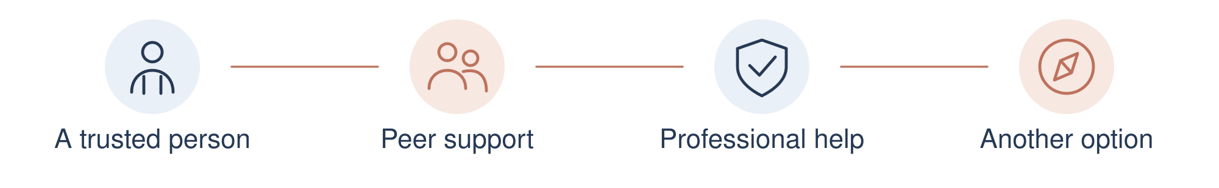
01 What company is around me and how connected I feel

02 Whether I want quiet, company, a meaningful conversation or a mixture

03 What helps me feel heard rather than simply surrounded

04 Who or what support feels appropriate and available

05 One manageable way I could make room for that need

If the first option is unavailable, I can try another. Connection is something I can ask for; it is not something I have to earn.

05 RECOGNISING THE DIFFERENCES Date __________

Love and being in love
RECOGNISING OVERLAP AS WELL AS DIFFERENCE
These are everyday words, and people use them differently. I use the following descriptions to reflect, rather than to decide what anyone else must feel.
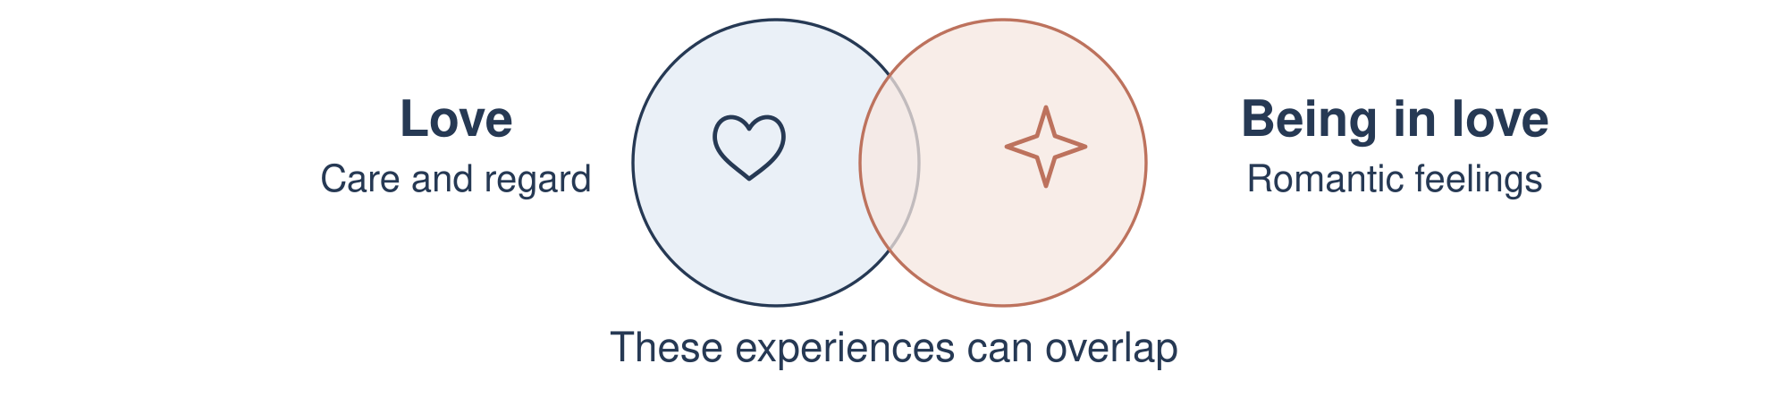

Love
Here, love means affection, care and regard for someone. It can be romantic or part of friendship, family life and other caring relationships. I can notice it in ordinary actions, respect and concern for someone's wellbeing.

Being in love
Here, being in love means feeling romantically drawn to someone. It may involve longing, excitement and a wish for closeness. Romantic feelings vary between people and can change over time. [10, 11]
The two can exist together. Caring companionship and romantic feelings can overlap, and romantic love can last. Intensity by itself cannot tell me whether a relationship is safe or right for me. [10, 11]
01 What words fit my experience and what care looks like in practice

I can notice respect, consent and freedom to say no, as well as the strength of a feeling.
References 10 and 11 provide further reading. These descriptions and prompts are not a relationship test. Sources and links are on pages 40 to 42.

05 RECOGNISING THE DIFFERENCES Date __________

What love looks like in my life
CARE FEELINGS AND RESPECT
Write about a partner, friend, family member or caring relationship only if you want to. You can also reflect on what you hope for in a future relationship.
01 What I feel and which words I would use for it

02 How I show care through ordinary actions

03 How care and respect are shown towards me

04 What I notice about consent, boundaries and my freedom to say no

05 What I need or want to talk about when it is safe

Strong feelings do not require an immediate decision. If someone is unsafe or abusive, seek support; this page does not ask you to confront them.

05 RECOGNISING THE DIFFERENCES Date __________

Guilt and shame
BEHAVIOUR RESPONSIBILITY AND HOW I SEE MYSELF
A useful starting distinction is whether my attention is on a particular action or on condemning my whole self. It is a guide to reflection, not a rule that describes every experience. [12, 13]
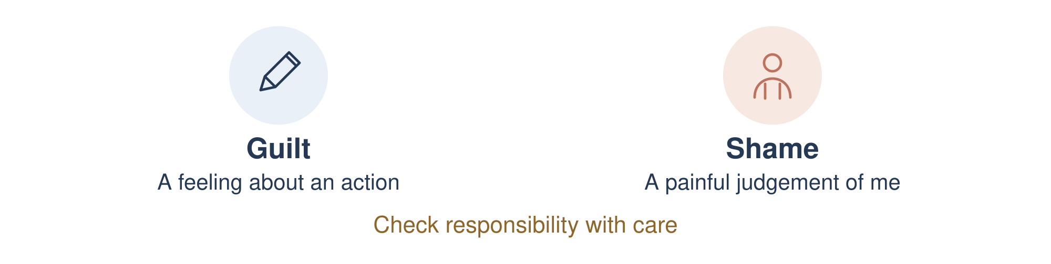

Guilt
Guilt often concerns something I did, or did not do, that I believe was wrong. If that belief fits the facts, it can invite a specific repair or change. Feeling guilty does not automatically mean I am responsible. [12]

Shame
Shame can involve a painful judgement that I am inadequate or unacceptable as a person. One mistake may start to feel like a verdict on my entire worth. Guilt and shame can coexist, and their meanings are debated. [12, 13]
Illustrative example: I regret missing a promise names an action. I am worthless judges the whole person. A kinder response can still be honest about the missed promise and what I can do next.
01 Am I naming an action, judging myself, or experiencing both

Being harmed as a child was not your responsibility. There is no apology owed for another person's abuse or neglect.
References 12 and 13 support the discussion. The example and exercise are original. Sources and links are on pages 40 to 42.

05 RECOGNISING THE DIFFERENCES Date __________

Responsibility with kindness
HONESTY WITHOUT ATTACKING MY WHOLE SELF
Choose something manageable. I can check the facts before accepting blame. Where I have caused harm, kindness can include accountability and a safe, appropriate repair.
01 The action I regret or the judgement I am hearing

02 What I actually know and what I still need to check

03 Responsibility that is mine and what was outside my control

04 If a repair fits, what could be appropriate and safe

05 A kind and accurate sentence I could say to myself

An apology does not require an unsafe meeting or guarantee forgiveness. I can ask for support when deciding how to respond.

05 RECOGNISING THE DIFFERENCES Date __________

The QSR reflection model
AN ORIGINAL PERSONAL REFLECTION MODEL
I have made this simple QSR model for this workbook: Question gently, Separate with care, Respond kindly. It is a way to organise a reflection, based on my understanding. It is not a tested therapy, assessment or professional treatment.
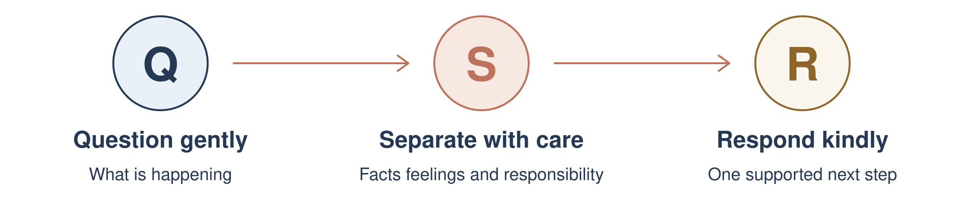

Q Question gently
What is happening, and what am I feeling? Describe an ordinary moment without forcing a childhood explanation. Pause first if you need to.

S Separate with care
What are the facts, what is a feeling, and what am I assuming? Check the distinctions that help: company and connection; caring and romantic feelings; a specific action and a judgement of my whole self. More than one description may fit.

R Respond kindly
What do I need, and what is one safe next step? It may be rest, connection, a boundary, asking for support or a specific repair where responsibility is mine.
01 Which part of this model would help me slow down today

I do not need a perfect answer. I can stop, return later or ask for help.

05 RECOGNISING THE DIFFERENCES Date __________

The model in everyday life
ILLUSTRATIVE EXAMPLES | NOT DESCRIPTIONS OF YOU
These examples show how the same model can be used for different questions. They do not decide what your own experience means.
Situation | Q Question | S Separate | R Respond
Alone or lonely | I am by myself and would like someone to listen. | My company is limited; I want more connection. | Ask a trusted person for a short conversation, or try another available support.
Love or being in love | I feel romantic attraction and want to know this person. | Attraction and ongoing care can overlap. Intensity alone does not establish compatibility. | Take time, notice respect and talk about expectations when safe.
Guilt or shame | I broke a promise and am calling myself worthless. | The missed promise needs attention; it does not define my entire worth. | Consider a specific safe repair and a realistic change.

01 An example I would put into my own words

A kind next step can still include responsibility. The examples are possibilities, not instructions to contact someone.

05 RECOGNISING THE DIFFERENCES Date __________

My QSR reflection page
QUESTION GENTLY | SEPARATE WITH CARE | RESPOND KINDLY
Choose one everyday moment. Keep this private, write as little as you want and leave any question that does not fit.
01 Q What is happening and what am I feeling

02 S What are the facts, feelings and assumptions, and what is mine

03 R What do I need and what is one safe, kind next step

04 Who or what support could help me with that step

If I cannot find a clear answer, I can pause and ask for help.

06 EVERYDAY KINDNESS Date __________

The way I speak to myself
Choose one self-critical sentence you notice. Try a response that is both kind and believable. You do not need to replace it with praise that feels false.
Illustrative example: I always ruin everything could become I regret how I handled that conversation. I can take a breath, ask for help and decide on an appropriate repair. This example is not a diagnosis or a description of you.
01 A harsh sentence I notice saying to myself

02 What I might say to someone I cared about in this situation

03 A kinder and more honest sentence I can try for myself

Kindness can include a boundary, rest, honesty or asking for help.

06 EVERYDAY KINDNESS Date __________

Compassionate self discovery
ORIGINAL REFLECTION | YOUR OWN UNDERSTANDING
Be curious about one part of your life today. There is no hidden correct answer. Stay with what you can notice, and leave any question that feels intrusive.
01 What am I finding difficult at the moment

02 What might I be trying to protect or care for

03 What do I need that I have not yet made room for

04 What is a respectful next step for myself and other people

Maté's broad emphasis on compassion is acknowledged in reference 1. This page is not Compassionate Inquiry training or a therapy protocol. Sources and links are on pages 40 to 42.

06 EVERYDAY KINDNESS Date __________

Understanding a difficult moment
Choose a recent everyday moment that feels manageable. You can write about it without analysing your whole history.
01 What happened in plain facts

02 What I felt or noticed in myself

03 What I thought it meant

04 What I did and what effect that had

05 What I want to practise differently with support

Understanding a reaction can help me choose what I do next. It does not decide what another person intended.

06 EVERYDAY KINDNESS Date __________

Boundaries that show care
A boundary can protect time, privacy, energy or safety. Choose one that is realistic in your circumstances. If someone is abusive or unsafe, get appropriate support; this page does not ask you to confront them.
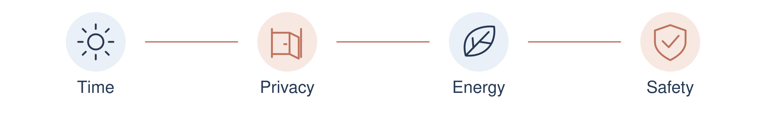
01 Something I need to protect or make room for

02 A clear sentence I could use when it is safe to do so

03 What action is within my control if the boundary is not respected

A boundary can be quiet and ordinary. I can choose how much I explain.

06 EVERYDAY KINDNESS Date __________

Connection and asking for help
Meetings and honest conversations matter in my own recovery. For you, support might include a trusted person, peer group, GP or qualified professional. Choose what feels appropriate and accessible.
01 Someone or a service I could approach

02 What I would like help with

03 A short way to ask for that help

04 Another option if the first person or service is unavailable

You do not have to share every detail to ask for support. This writing can stay private.

06 EVERYDAY KINDNESS Date __________

A day of care
Ordinary routine is part of what helps me. Use this space to plan a day that fits your health, energy and circumstances. It can be adjusted at any time.
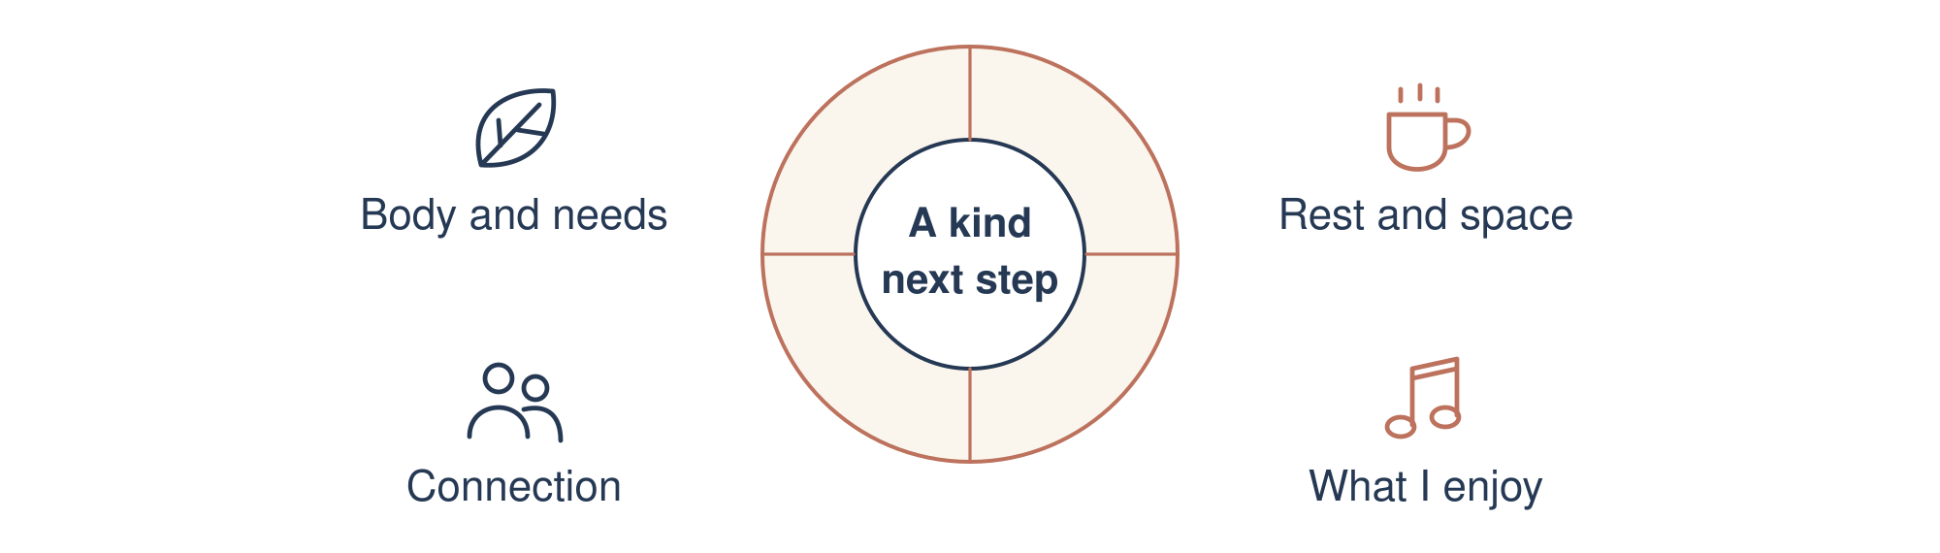
01 One thing that could help me begin the day

02 Food, rest, movement or another basic need I want to attend to

03 A moment of connection or something from my love list

04 A kind way to end the day and notice what I need next

An incomplete plan is information about what I need. I can make the next plan smaller.

07 LOOKING AFTER MYSELF Date __________

A plan for a difficult day
CARE AND SUPPORT FIRST
Put the workbook aside if it is making the day harder. Return to an ordinary activity, a safer place or someone you trust. You do not need to finish an exercise before asking for help.
01 Signs that I need to stop and get support

02 The person or service I will try and an alternative

03 One immediate practical thing that could make the next hour easier

When urgent help is needed
If you cannot keep yourself or someone else safe, or a life is at risk, call 999 or go to A&E. In England, urgent mental health help is available through 111; select the mental health option. [7]
For someone to listen, Samaritans can be called free on 116 123 in the UK and Ireland, day or night. It is a listening service, not an emergency response. Outside these areas, use local services. [8]
A self-guided workbook cannot provide urgent care or replace a personal care plan.

07 LOOKING AFTER MYSELF Date __________

Noticing what is changing
There is no score for completing this workbook. Notice what is becoming clearer, what feels useful and what you would like to leave alone for now.
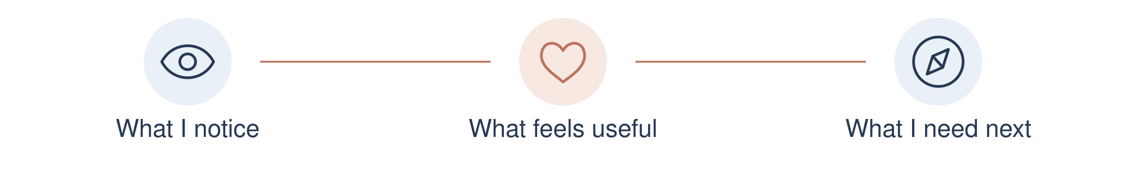
01 Something I understand about myself a little better

02 A small moment when I treated myself with care

03 A behaviour or boundary I want to keep practising

04 What I need more support with

An honest observation counts, even when the week has been difficult.

07 LOOKING AFTER MYSELF Date __________

A letter for the weeks ahead
A MANAGEABLE MESSAGE TO MYSELF
Write a message you could read on an ordinary or difficult day. You might name something you care about, a source of support and one realistic promise of care. Leave room for changing needs.

You can come back and change these words as life changes.

SOURCES AND SUPPORT

Sources and influences
ACKNOWLEDGEMENT AND FURTHER READING
This is an independent workbook by Chris Nugent. It draws on broad ideas and my own recovery understanding. The letters, lists, photograph prompts and hand-writing experiment are original exercises; they are not reproduced from the sources below.
References identify an influence or provide further information. They do not imply that an author or organisation has reviewed, approved or endorsed this workbook. No clinical effectiveness is claimed for these exercises.

1 Gabor Maté on addiction and compassion
His official website describes his perspective on emotional pain, stress and compassion. I acknowledge this as an influence on my curiosity about coping and recovery.
https://drgabormate.com/about/

2 Gabor Maté with Daniel Maté
The Myth of Normal: Trauma, Illness and Healing in a Toxic Culture. The official book page gives an introduction and publication links. This is further reading, not a source of copied workbook exercises.
https://drgabormate.com/book/the-myth-of-normal/

3 Adult Children of Alcoholics and Dysfunctional Families
Welcome Path introduces the ACA fellowship and its family recovery focus. ACOA is a name often used for this adult children recovery tradition.
https://adultchildren.org/welcome-path/

4 ACA on caring for the younger self
Becoming Your Own Loving Parent is official ACA introductory material. Its broad emphasis on gentleness and self-care is acknowledged. ACA texts, Steps and published worksheets are not reproduced here.
https://adultchildren.org/newcomer-becoming-your-own-loving-parent/

SOURCES AND SUPPORT

Support and publication notes
FURTHER INFORMATION | OCTOBER 2026

5 National Institutes of Health
Substance Use Disorders explains that addiction risk has several contributing factors. Trauma may be one factor; it is not a universal explanation.
https://health.nih.gov/health-topics-a-z/substance-use-disorder

6 NHS information on PTSD
For symptoms that are troubling you, speak to a GP or appropriate mental health professional. This workbook does not assess or treat PTSD.
https://www.nhs.uk/mental-health/conditions/ptsd-post-traumatic-stress-disorder/

7 NHS urgent mental health help
England: call 111 and choose the mental health option for urgent help. If a life is at risk or you cannot keep yourself or someone else safe, call 999 or go to A&E.
https://www.nhs.uk/nhs-services/mental-health-services/where-to-get-urgent-help-for-mental-health/

8 Samaritans
UK and Ireland: free listening support on 116 123, day or night. Refer to its official page for current access information.
https://www.samaritans.org/how-we-can-help/contact-samaritan/
Reference pages checked 10 October 2026. The source list supports attribution and further reading; it is not evidence that this workbook is a tested intervention.
Independent QSR publication. Chris Nugent is not a therapist or clinical professional. Original text and workbook design prepared for Chris Nugent. Source material remains the property of its respective owners. Referenced material is linked rather than reproduced.
Project website: https://quietstrengthrecovery.co.uk/
Please keep completed pages and personal photographs private unless you choose to share them.

SOURCES AND SUPPORT

Sources for the reflection model
ACKNOWLEDGEMENT AND FURTHER READING
These sources inform the distinctions on pages 22 to 27. The QSR reflection model, examples and writing prompts are original to this workbook and have not been assessed or endorsed by these authors or organisations.

9 US Surgeon General
Our Epidemic of Loneliness and Isolation, 2023. The advisory distinguishes the experience of loneliness from the circumstances of social isolation.
https://www.hhs.gov/sites/default/files/surgeon-general-social-connection-advisory.pdf

10 Robert J Sternberg
His official Love page discusses different aspects of love and their overlap. This workbook does not reproduce his model, illustrations or scales.
https://www.robertjsternberg.com/love

11 Adam Bode and Geoff Kushnick
Proximate and Ultimate Perspectives on Romantic Love, 2021. A research review discussing romantic and companionate love, including their overlap and variation over time.
https://doi.org/10.3389/fpsyg.2021.573123

12 American Psychological Association
Speaking of Psychology interview with June Tangney on guilt and shame. Further reading on distinguishing a behaviour from a judgement of the self.
https://www.apa.org/news/podcasts/speaking-of-psychology/guilt-shame

13 Maria Miceli and Cristiano Castelfranchi
Reconsidering the Differences Between Shame and Guilt, 2018. This paper explains that distinctions are debated and the experiences can coexist.
https://doi.org/10.5964/ejop.v14i3.1564
References checked 10 October 2026. This is my personal understanding, not professional advice. A reference does not demonstrate that the exercises or model are clinically effective.

08 UNDERSTANDING THE TASKS

What these tasks are meant to help with
I included these tasks to give you space to understand yourself, recognise what you need and think about how you want to respond. This section explains what each task is intended to offer. The page numbers take you back to the exercise.
These are aims for your own reflection, not promised results. You can finish with one useful sentence, leave a page blank or decide that a task is not right for you. You do not have to feel better immediately for your reflection to matter.

Before I begin
Page 4
The aim is to make your own limits clear before you start. You decide what would make this a manageable time, what tells you to pause and who you could turn to. A useful outcome is having a way to stop and return to an ordinary activity without feeling you must finish the page.

What I understand about trauma
Page 5
This page gives you room to say what you want to understand about yourself today. It is meant to help you choose a personal reason for using the workbook, such as understanding a reaction or the way you speak to yourself. You do not need a diagnosis or an explanation for every part of your past.

What helps me
Page 6
The purpose is to recognise support that already matters to you and make it easier to use. That might mean noticing that a conversation, a meeting or an ordinary routine helps you feel connected. The practical outcome is one thing you would like to keep doing, with the support needed to make it realistic.

08 UNDERSTANDING THE TASKS

Patterns needs and writing

What I learnt to do
Page 7
The aim is to understand one habit before judging yourself for it. A habit such as staying quiet may have helped you manage a difficult situation. Looking at when it helps and when it gets in the way gives you a clearer choice about what to keep or practise differently now. You do not have to prove where it began.

What I need today
Page 8
This task is meant to turn a difficult feeling into a more specific question about what you need. Instead of stopping at I am struggling, you might recognise that you need rest, clearer information or someone to listen. The useful outcome is naming one need and one realistic way to ask for or make room for it.

Writing with my other hand
Pages 9 to 10
This optional experiment is there to let you try a different pace and notice how writing feels. Untidy words are allowed. The outcome can simply be learning which way of expressing yourself you prefer. It does not reveal hidden truths or recover memories. Your usual hand, typing or leaving the exercise are equally valid choices.
Understanding a pattern does not require changing it all at once. A small choice might be asking a question instead of automatically agreeing, or noticing that you need a break. Choose something that fits your circumstances.

08 UNDERSTANDING THE TASKS

Letters and the younger self

Letter to my younger self
Pages 11 to 12
The purpose is to offer a younger version of yourself words of care and recognition. You might name something that child deserved, such as protection, patience or being heard. One honest, kind sentence can be enough. The letter is written from today; it does not establish what happened or require forgiveness or contact with anyone.

Letter to myself as an adult
Pages 13 to 14
This letter is meant to hold kindness and responsibility together. You can recognise effort and pain while naming a behaviour you want to change. A useful outcome is being able to say what you need and make one manageable promise to yourself, without turning a mistake into a judgement of your whole worth.

Looking at a younger photograph
Page 15
The photograph is an optional way to make a message of care more personal. Looking at the younger person in the picture gives you somewhere to direct a kind sentence. Stay with what you can actually see; the photograph cannot fill gaps in your history. A written name or a current photograph can serve as an alternative.

Offering kindness to that child
Pages 16 to 17
The aim is to put care into words and think about how to show that care now. An apology, if you choose one, can concern the harsh way you have treated yourself as an adult. You are not responsible for abuse or neglect you experienced as a child. Comfort or acknowledgement is enough; no apology is required.

08 UNDERSTANDING THE TASKS

Fears and what matters to me

My fears list
Page 18
The purpose is to give a name to worries you choose to look at. A list can make it clearer which concern you want help with, rather than leaving everything as one large worry. It is not a challenge to list every fear or face them all. Naming one concern and recognising that it matters is enough.

Working gently with one fear
Page 19
The aim is to separate what you know from what you are assuming, and notice what is within your control. That makes the next question more practical: what reassurance, help or protection do I need? The outcome is one supported next step. If the fear concerns real danger, protection and support come first.

My love list
Page 20
This task makes room for parts of life you care about alongside the difficult things. People, animals, music, places or a quality you value can all belong here. The useful outcome is a personal reminder of what matters to you. You can write things I like instead; there is no requirement to feel positive.

Making room for what I love
Page 21
The purpose is to take one item from your love list and give it a little space in everyday life. You might make time for a song, a short walk or an ordinary conversation. The outcome is a realistic plan you can try and adjust, so something you value has a place beyond the written list.

08 UNDERSTANDING THE TASKS

Understanding the differences

Being alone or feeling lonely
Pages 22 to 23
These pages are meant to help you describe the connection you actually need. Being by yourself and feeling unheard are different questions, and both can matter. You might want quiet, company or a meaningful conversation. The practical outcome is choosing a kind of connection that fits today, rather than assuming that any company will do.

Love and being in love
Pages 24 to 25
The purpose is to look at feelings alongside how people treat each other. Romantic attraction, affection and everyday care can overlap. These pages give you room to notice respect, consent and your freedom to say no. A useful outcome is clearer words for what you feel and what you need, without pressure to make an immediate decision.

Guilt and shame
Pages 26 to 27
The aim is to check whether you are naming an action, accepting blame that is not yours or condemning your whole self. Where responsibility is yours, you can consider a specific, safe repair. The outcome is a more accurate account of what happened and a response you can act on, while still treating yourself with respect.

The QSR reflection model
Pages 28 to 30
Question gently means noticing the moment and your feelings. Separate with care means checking facts, feelings and assumptions. Respond kindly means choosing one safe next step. The model is meant to organise your reflection so it leads to a choice, rather than another round of judging yourself. It is my personal model, not a tested therapy.

08 UNDERSTANDING THE TASKS

Kindness in everyday actions

The way I speak to myself
Page 31
The purpose is to notice a harsh sentence and try words that are kinder and still believable. You can be honest about a mistake without calling yourself worthless. The useful outcome is one sentence you could actually use next time, such as I regret what I said and I can think about an appropriate repair.

Compassionate self discovery
Page 32
This task invites curiosity about what is difficult and what you may be trying to protect or care for. It is meant to make room for a need you have not yet named. The outcome might be a clearer question to discuss with someone you trust, or one respectful next step. There is no hidden answer you must uncover.

Understanding a difficult moment
Page 33
The aim is to look at the link between an event, your interpretation and what you did next. Separating these parts gives you something specific to reflect on. The useful outcome is noticing one response you would like to practise differently, with support where needed. It does not tell you what someone else was thinking or intending.

Boundaries that show care
Page 34
The purpose is to make a limit clearer and think about what is within your control. You name what needs protecting, find a sentence you could use and consider your own next action. The outcome is a realistic boundary, rather than a plan to change another person. If using it would be unsafe, seek appropriate support.

08 UNDERSTANDING THE TASKS

Support and moving forward

Connection and asking for help
Page 35
The aim is to make asking for support more concrete. You identify a person or service, what you need and a short way to ask. A useful outcome is knowing who you could approach and having another option if they are unavailable. You do not have to share your whole history to ask for help.

A day of care
Page 36
This task gives ordinary needs a place in a day that fits your circumstances. The purpose is to choose manageable care, such as food, rest or connection. The outcome is a plan you can adjust. If it is too much, making it smaller is a useful response, rather than another reason to criticise yourself.

A plan for a difficult day
Page 37
The aim is to decide in advance what tells you to pause, who you can contact and what might help with the next hour. The practical outcome is having those choices written down when thinking feels harder. Use your existing care plan where you have one, and get urgent help when needed.

Noticing what is changing
Page 38
The purpose is to recognise what is useful and where you still need support. A change might be asking for help sooner or speaking to yourself with more care. The outcome is one honest observation to carry forward. Completing more pages is not a score, and a difficult week does not cancel your effort.

A letter for the weeks ahead
Page 39
This letter is meant to leave a reminder in your own words of what matters, what support is available and what you would like to keep practising. The outcome is a message you can return to and change as life changes. Keep any promise small enough to be realistic on an ordinary day.
For me, the point is to understand myself a little more clearly and put that understanding into how I live. Your useful next step may be a kinder sentence, a clearer boundary or asking for support. Choose what fits you. Sources and support remain on pages 40 to 42.

